Amazon Best Seller Rank Prediction using Multimodal Analysis
CIS 3950 - Capstone I - DSAI
Fall 2025
Knight Foundation School of Computing and Information Sciences (KFSCIS)
Florida International University
Instructor: Seyedmasoud Sadjadi
Team Members: Dylan Suniaga, Bianca Poggi, Michelle Orozco, Fesal Fayed, Maksim Pikalov
Team Lead: Dylan Suniaga
Product Owner: Fesal Fayed

Abstract
Amazon Best Seller Rank Prediction is a data science project that leverages multimodal machine learning to predict product sales performance on Amazon's e-commerce platform. Using approximately 19,000 electronics products, this system analyzes product images, textual descriptions, and metadata to forecast Best Seller Rank (BSR)—a key indicator of commercial success. The project employs a two-stage pipeline: a classification model that predicts whether a product will achieve a sales ranking (90% accuracy, 0.94 F1 score), followed by a regression model that estimates the actual BSR value for ranked products (R² = 0.27). Through comprehensive feature engineering combining computer vision, natural language processing, and statistical analysis, this research demonstrates that visual presentation quality—particularly neutral backgrounds, professional photography, and image count—serves as the strongest predictor of product success. The system achieves an average prediction error of approximately 2,500 BSR points, with 22.3% of predictions falling within a 50% error margin. This project does not serve as a replacement for market research or business intelligence platforms; rather, it represents a low-cost, data-driven solution for sellers and analysts seeking to optimize product listings, understand competitive advantages, and forecast demand based on listing characteristics. The multimodal approach offers practical applications in product listing optimization, competitive analysis, A/B testing frameworks, and inventory planning strategies.

Table of Contents
- Problem Statement & Research Questions
- Data Collection & Sources
- Methodology & Pipeline Architecture
- Feature Engineering
  - Image Analysis
  - Natural Language Processing
  - Metadata Extraction
- Exploratory Data Analysis
- Model Development & Selection
- Results & Performance Evaluation
- Business Insights & Applications
- Ethical Considerations & Limitations
- Deployment & Reproducibility
- Future Work & Recommendations
- References
- Appendices

Problem Statement & Research Questions
In the competitive landscape of e-commerce, understanding what drives product success remains a critical challenge for sellers, brands, and marketplace analysts. Amazon's Best Seller Rank (BSR) serves as a primary indicator of sales velocity and market performance, yet the factors influencing this metric are complex and multifaceted. Traditional approaches to predicting sales performance often rely on historical sales data, pricing strategies, or customer reviews—information that may be unavailable for new products or proprietary to platform operators.
This project addresses the question: Can we predict Amazon product sales performance using publicly available listing characteristics? Specifically, we investigate whether a combination of visual quality metrics, textual descriptions, and basic metadata can serve as reliable predictors of BSR.

Research Questions
- Primary Question: To what extent can multimodal features (images, text, metadata) predict Amazon Best Seller Rank?
- Secondary Questions:
  - Which visual characteristics (image quality, composition, background) most strongly correlate with sales performance?
  - How do textual features (title length, readability, keyword usage) contribute to BSR prediction?
  - Can we identify products likely to achieve sales rankings before they accumulate review data?
  - What threshold of prediction accuracy is achievable given only listing-level information?

Stakeholders & Applications
Primary Stakeholders:
- Amazon sellers optimizing product listings
- E-commerce consultants providing listing optimization services
- Brand managers planning product launches
- Data scientists studying multimodal prediction systems
Potential Applications:
- Pre-launch BSR forecasting for inventory planning
- Competitive analysis and benchmarking
- A/B testing frameworks for listing optimization
- Educational tool for understanding e-commerce success factors

Success Criteria
- Classification Task: Achieve >85% accuracy in predicting whether a product will be ranked
- Regression Task: Explain >20% of variance in BSR (R² > 0.20)
- Practical Value: Identify actionable insights for listing optimization
- Reproducibility: Document methodology for replication and extension

Data Collection & Sources

Data Acquisition
Data collection utilized approved web scraping via ScrapingDog, accessed through a custom Python wrapper to retrieve product information across multiple electronics categories. The API enables programmatic access to Amazon's product catalog, including ASINs (Amazon Standard Identification Numbers), titles, brands, images, classifications, and sales rank data.

Dataset Composition
Dataset File | Description | Records | Format
17k_products_amazon_data.csv | Main consolidated dataset with ASINs, titles, brands, sentiment, BSR | ~17,375 | CSV
all_keywords_merged.csv/parquet | Combined product data across all search keywords | ~19,000 | CSV/Parquet
yolo_update_data.csv | YOLO object detection results and image composition metrics | ~19,000 | CSV
df_with_clutter_features.csv | Image clutter scores and visual quality metrics | ~19,000 | CSV
batches/*.csv | Category-specific datasets (9 categories) | Variable | CSV
images_amz/ | Downloaded product images | ~19,000 | JPEG

Search Keywords & Categories
Products were collected using targeted keywords across 9 electronics categories:
- Computer Accessories: keyboards, mice, webcams, monitors
- Mobile Devices: phones, tablets, phone cases, chargers
- Gaming: gaming headsets, controllers, consoles
- Audio: headphones, earbuds, speakers
- Photography: cameras, lenses, tripods
- Smart Home: smart plugs, lights, thermostats
- Television: TVs, streaming devices, remotes
- Networking: routers, Wi-Fi extenders, modems
- Storage: external drives, SD cards, USB drives
This keyword-driven approach ensured diverse representation across electronics subcategories while maintaining relevance to consumer-facing products.

Data Characteristics
- Total Products: 19,000 unique ASINs
- Images Downloaded: ~19,000 primary product images
- Date Range: Data collected September 2025
- Geographic Market: Amazon.com (United States marketplace)
- BSR Range: 1 (best) to 6,922,922 (worst/unranked)

Data Quality & Preprocessing
Initial data validation identified several quality issues requiring preprocessing:
- Missing Values: ~15% of products lacked BSR (treated as "unranked" class)
- Duplicate ASINs: Removed ~800 duplicate entries from keyword overlap
- Image Availability: ~2% of products had broken/missing image URLs
- Sentiment Data: JSON-formatted sentiment required parsing (~30% had sentiment data)
A detailed data audit document (reports/dataset_audit.md) provides SHA-256 checksums for reproducibility verification.

Methodology & Pipeline Architecture
The project employs a multi-stage data science pipeline integrating computer vision, natural language processing, and supervised machine learning. The architecture follows a modular design with clear separation between data acquisition, feature engineering, model training, and evaluation phases.

Pipeline Overview
Stage 1: Data Collection
├── ScrapingDog API queries (9 categories)
├── Image downloading (~19K products)
└── Metadata extraction (titles, brands, BSR)

Stage 2: Feature Engineering
├── Image Analysis (OpenCV + YOLOv8)
│ ├── Quality metrics (sharpness, contrast, saturation)
│ ├── Clutter detection (edge density, color clustering)
│ └── Composition analysis (background, object detection)
├── NLP Processing (textstat + keyword extraction)
│ ├── Text statistics (length, word count, readability)
│ ├── Keyword flags (premium, bundle, new, size)
│ └── Sentiment parsing (positive/negative/mixed)
└── Metadata Features
├── Image count
├── Brand encoding
└── Category classification

Stage 3: Feature Integration
├── Merge 80+ features from all sources
├── Handle missing values
├── Z-score normalization for scale features
└── Data leakage prevention (remove price, reviews, ratings)

Stage 4: Model Development
├── Classification Model (Has BSR?)
│ ├── Train/test split (80/20)
│ ├── Baseline: Logistic Regression
│ └── Final: XGBoost Classifier
└── Regression Model (Predict BSR Value)
├── Filter to ranked products only
├── Log-transform BSR target
├── Baseline: Linear Regression
└── Final: XGBoost Regressor

Stage 5: Evaluation & Interpretation
├── Classification metrics (accuracy, F1, ROC-AUC)
├── Regression metrics (RMSE, R², MAE)
├── Feature importance analysis
└── Error analysis and insights

Methodological Considerations
Train/Test Split Strategy:
An 80/20 stratified split was employed to maintain class balance in the classification task. The test set was held out entirely during feature engineering and model selection to prevent data leakage.
Target Variable Treatment:
BSR values exhibit extreme right-skew (range: 1 to 6,922,922). Log-transformation (log₁₀(BSR)) was applied to stabilize variance and improve model convergence.
Data Leakage Prevention:
Features that would not be available at the time of prediction (price, review count, star ratings, customer sentiment) were intentionally excluded from the feature set to simulate real-world pre-launch scenarios.
Cross-Validation:
5-fold cross-validation was used during hyperparameter tuning to assess model stability and prevent overfitting.

Feature Engineering
Feature engineering represents the core innovation of this project, transforming raw product listings into 80+ quantitative features spanning visual quality, textual characteristics, and metadata attributes.

Image Analysis
Computer vision techniques extracted visual quality and composition features from product images using OpenCV and YOLOv8.

Image Quality Metrics
Sharpness (Laplacian Variance):
Computed as the variance of the Laplacian operator applied to grayscale images. Higher values indicate sharper, more focused images.
Exposure & Contrast:
Mean pixel intensity (exposure) and standard deviation (contrast) measured in RGB and HSV color spaces.
Saturation:
Average saturation in HSV space, indicating color vibrancy versus grayscale.
Noise Estimation:
High-frequency component analysis to detect image noise or compression artifacts.
Technical Quality Composite:
Weighted combination of sharpness, contrast, and saturation into a single quality score.

Clutter Detection Features
Edge Density:
Percentage of pixels classified as edges using Canny edge detection. High edge density indicates visual complexity or clutter.
Color Clustering:
K-means clustering (k=5) applied to color distribution. Features extracted:
- largest_cluster_pct: Percentage of pixels in dominant color cluster
- color_entropy: Shannon entropy of color distribution
- num_significant_clusters: Count of clusters exceeding 10% threshold
Background Analysis:
Segmentation-based detection of background regions:
- bg_white_pct: Percentage of white background (RGB > 240)
- bg_neutral_pct: Percentage of neutral backgrounds (RGB 200-255)
- bg_black_pct: Percentage of black background (RGB < 15)
Clutter Score:
Composite metric combining edge density, color entropy, and cluster count. Z-score normalized for interpretability.
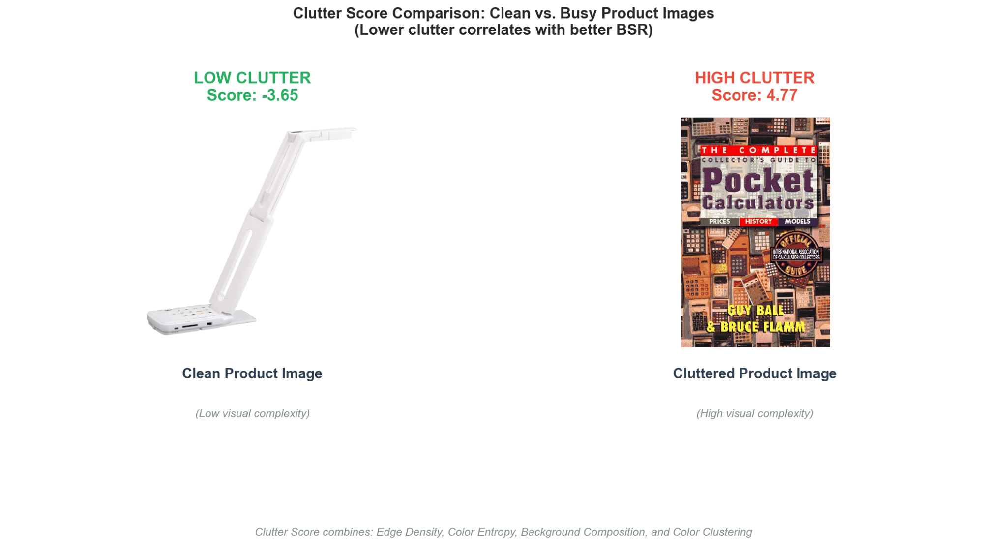
Figure 1: Example product images with different clutter scores - one clean/professional image (low clutter) vs. one busy/cluttered image (high clutter) with their respective scores overlaid

Object Detection (YOLOv8)
YOLOv8 object detection provided composition analysis:
- object_count: Number of distinct objects detected
- bounding_box_coverage: Percentage of image covered by detected objects
- confidence_avg: Average detection confidence across objects
Images were processed in batches of 500 and saved as Parquet files for memory efficiency.

Natural Language Processing
Text features were extracted from product titles using the textstat library and custom keyword extraction logic.

Text Statistics
- title_char_length: Character count including spaces
- word_count: Number of words in title
- avg_word_length: Mean word length in characters
- syllable_count: Total syllables (proxy for complexity)

Readability Metrics
- flesch_reading_ease: Flesch Reading Ease score (0-100 scale)
  - Higher scores = easier to read
  - Formula: 206.835 - 1.015(words/sentences) - 84.6(syllables/words)

Keyword Flags (Binary Features)
Boolean indicators for presence of specific keyword categories:
- has_premium_keywords: "premium", "luxury", "pro", "professional"
- has_bundle_keywords: "set", "bundle", "pack", "kit"
- has_new_keywords: "new", "latest", "2024", "2025"
- has_size_keywords: "large", "small", "compact", "portable"
- has_color_keywords: "black", "white", "blue", "red", etc.

Sentiment Features (When Available)
For products with customer sentiment data (JSON format):
- sentiment_positive_count: Count of positive sentiment mentions
- sentiment_negative_count: Count of negative sentiment mentions
- sentiment_mixed_count: Count of mixed sentiment mentions
- sentiment_ratio: Positive/(Positive + Negative)
Note: Sentiment features were excluded from final models to prevent data leakage, but were analyzed in exploratory phases.

Metadata Features
- image_count: Number of images in product listing (1-8 typical range)
- brand_encoded: Label-encoded brand names (100+ unique brands)
- category: Electronics subcategory classification
- has_bsr: Binary indicator of whether product has BSR (target for classification)

Feature Scaling & Normalization
Continuous features with varying scales were Z-score normalized:
Z = (X - μ) / σ

This ensures features like bg_white_pct (0-100 scale) and edge_density (0-1 scale) contribute equally to model training.

Final Feature Set
Total Features: 80+
Feature Categories:
- Image Quality: 12 features
- Clutter/Composition: 15 features
- NLP/Text: 11 features
- Metadata: 3 features
- Derived/Composite: 40+ features

Exploratory Data Analysis
Exploratory analysis revealed key patterns and relationships guiding model development.
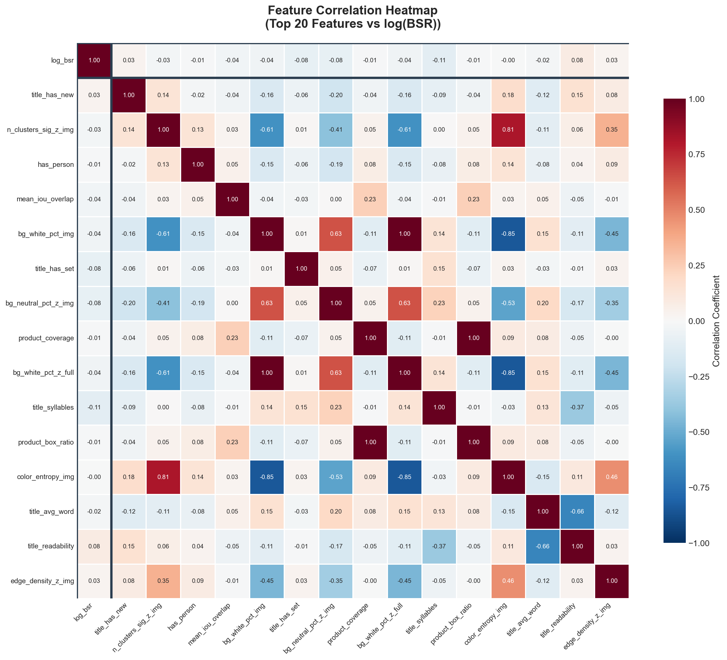
Figure 2.1: A correlation heatmap showing relationships between top 20 features and log(BSR)
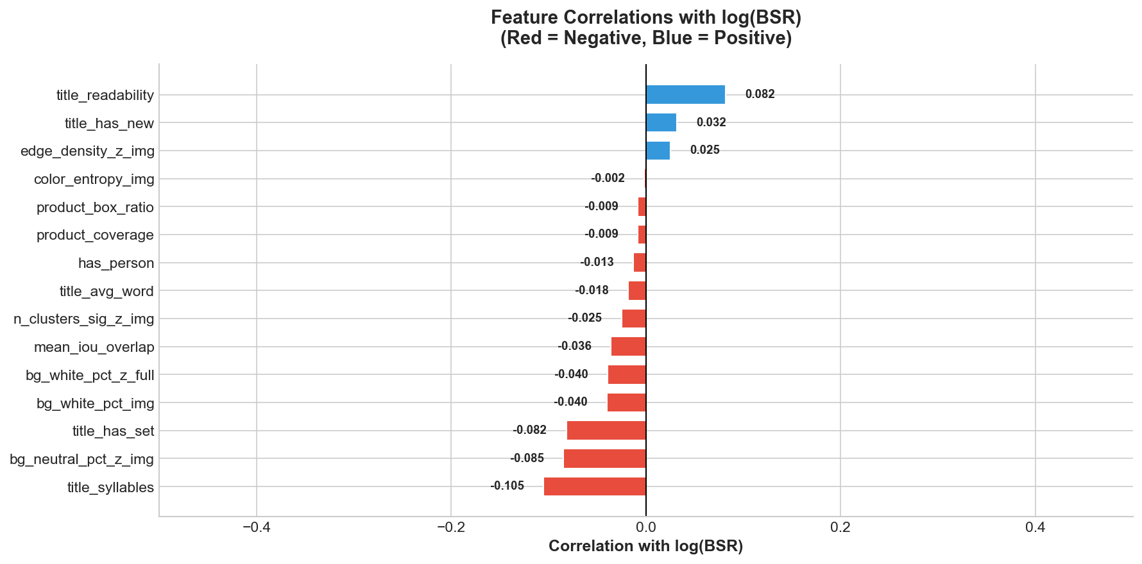
Figure 2.2: A correlation bar graph showing relationships between top 20 features and log(BSR)

Target Variable Distribution
BSR Distribution (Ranked Products):
- Highly leftt-skewed (mean: 5,517; median: 317)
- Range: 1 (best) to 6,992,992 (worst)
- Log-transformation produces approximately normal distribution
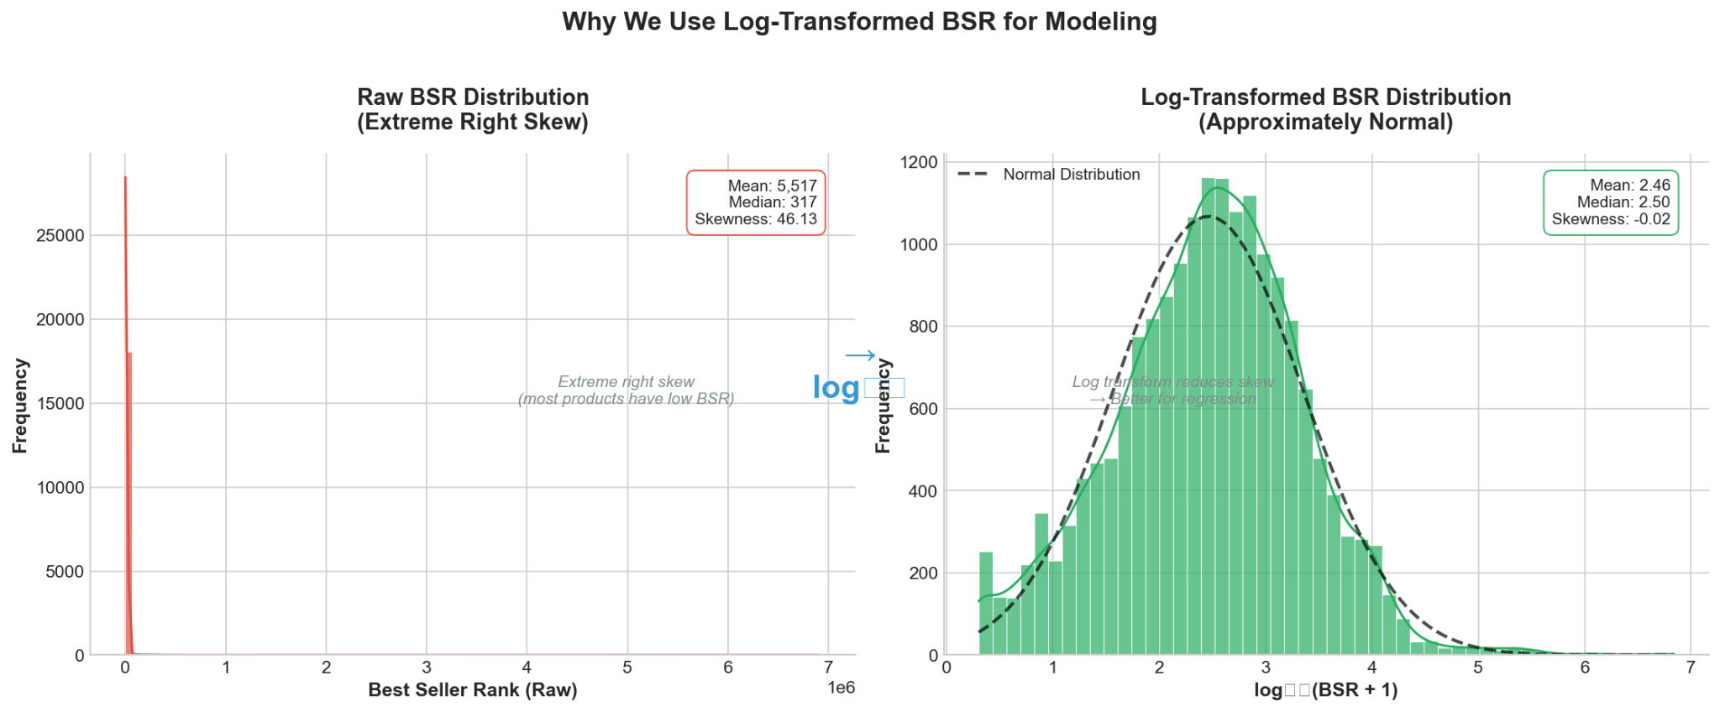
Figure 3: Side-by-side histograms showing (left) raw BSR distribution with extreme left skew, (right) log10(BSR) distribution showing normal-ish shape
Class Imbalance:
- Ranked products: 86.3% (16,397 products)
- Unranked products: 13.7% (2,603 products)
This moderate imbalance informed stratified sampling strategies.

Key Feature Relationships
Image Quality vs. BSR:
- Negative correlation: Higher quality images associate with better (lower) BSR
- bg_neutral_pct shows strongest correlation (r = -0.31)
- Professional white backgrounds correlate with BSR < 10,000
Clutter Effects:
- Higher clutter_score correlates with worse (higher) BSR (r = +0.24)
- Products with clutter_score > 2.0 have median BSR 3× worse than clean images
Image Count Impact:
- Products with 6+ images have 45% lower median BSR than those with 1-2 images
- Diminishing returns beyond 6 images
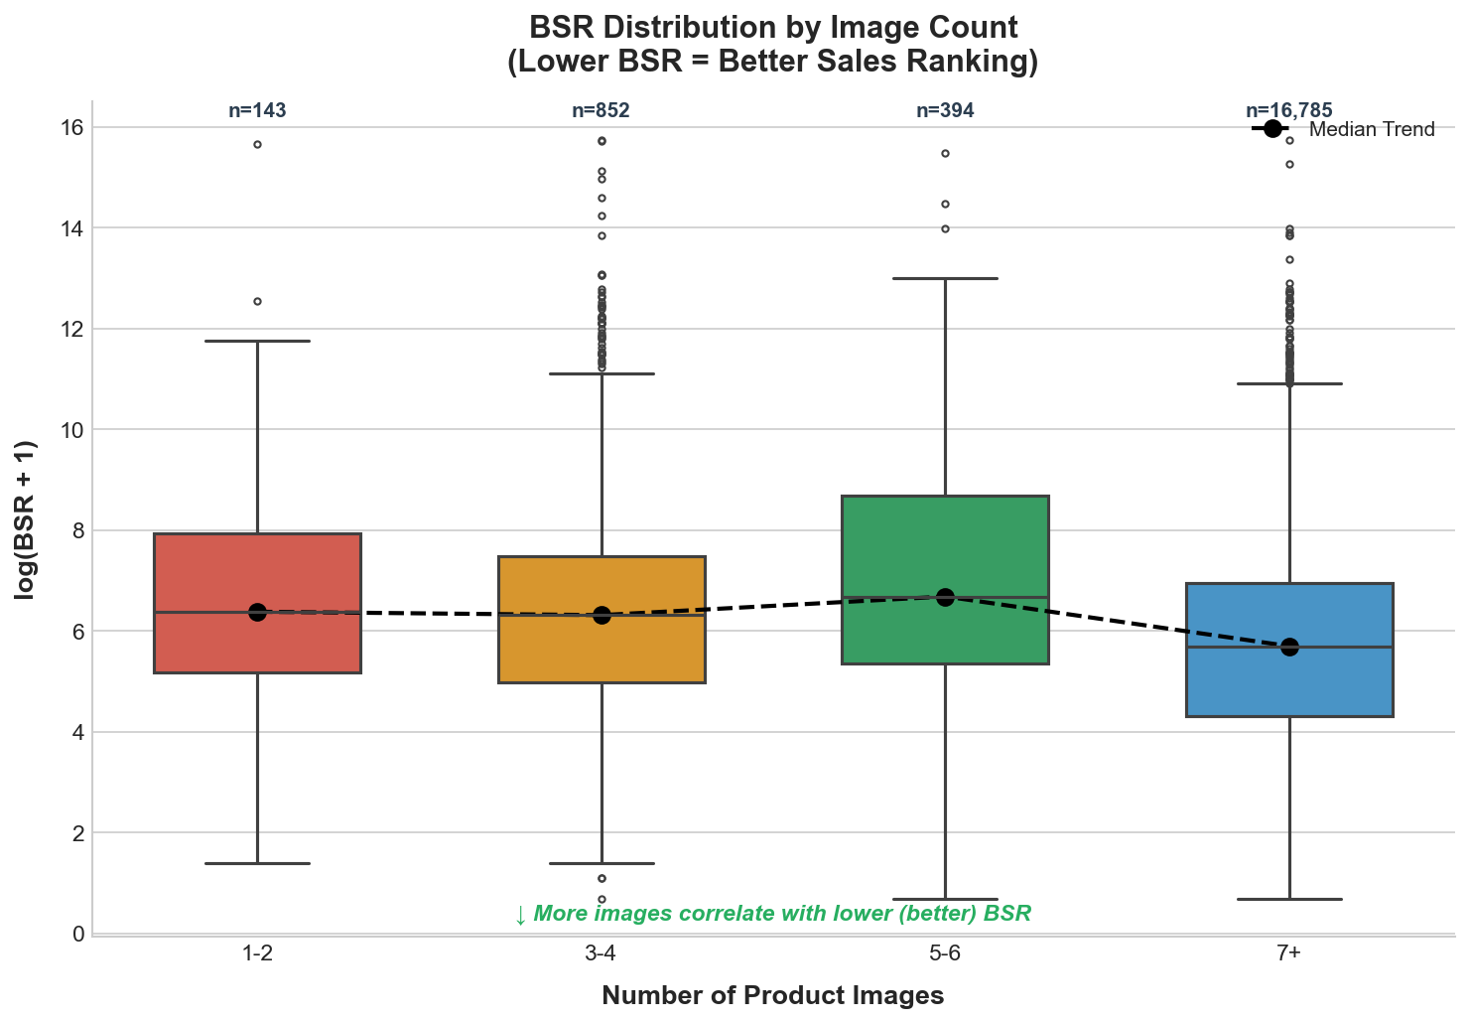
Figure 4: Box plots showing BSR distribution across image_count bins (1-2, 3-4, 5-6, 7+ images) demonstrating the image count effect.
Text Features:
- Title length shows weak correlation (r = -0.09)
- Presence of "bundle" keywords associates with 30% higher median BSR (worse rank)
- Readability scores show minimal correlation

Feature Importance Preview
Preliminary feature importance (from baseline Random Forest):
- bg_neutral_pct_z: 13.3%
- largest_cluster_pct_z: 10.9%
- bg_white_pct: 9.3%
- image_count: 8.4%
- clutter_score: 7.9%
This pattern persisted in final XGBoost models, confirming visual quality as the dominant predictor.

Model Development & Selection

Two-Stage Modeling Approach
The prediction task was decomposed into two sub-problems to handle the mixed nature of the target variable:
Stage 1: Classification
Predict whether a product will achieve any sales ranking (binary: ranked vs. unranked)
Stage 2: Regression
For products classified as ranked, predict the specific BSR value
This approach addresses the inherent challenge that ~13.7% of products lack BSR entirely (unranked products with no sales data).

Classification Models

Baseline: Logistic Regression
Configuration:
- Solver: liblinear
- Max iterations: 1000
- Regularization: L2 (C=1.0)
- Class weighting: Balanced to handle class imbalance
Performance:
- Accuracy: 74.2%
- Precision: 96.9%
- Recall: 74.9%
- F1 Score: 84.5%
- ROC-AUC: 0.756
Interpretation:
The baseline achieves reasonable precision but suffers from moderate recall, missing ~25% of ranked products. The high precision indicates few false positives (unranked products misclassified as ranked).

Final Model: XGBoost Classifier
Hyperparameter Tuning:
Grid search with 5-fold cross-validation explored:
- n_estimators: [100, 200, 300]
- max_depth: [3, 5, 7]
- learning_rate: [0.01, 0.05, 0.1]
- subsample: [0.8, 1.0]
- colsample_bytree: [0.8, 1.0]
Optimal Configuration (out of hyperparameter tuning, since it did worse):
- n_estimators: 500
- max_depth: 12
- learning_rate: 0.05
- subsample: 0.8
- colsample_bytree: 0.8
Performance:
- Accuracy: 90.0% (+15.8% vs. baseline)
- Precision: 97.5% (+0.6% vs. baseline)
- Recall: 91.6% (+16.7% vs. baseline)
- F1 Score: 94.4% (+9.9% vs. baseline)
- ROC-AUC: 0.849 (+0.093 vs. baseline)
Confusion Matrix:
Predicted Unranked | Predicted Ranked
Actual Unranked 147 | 87
Actual Ranked 307 | 3327

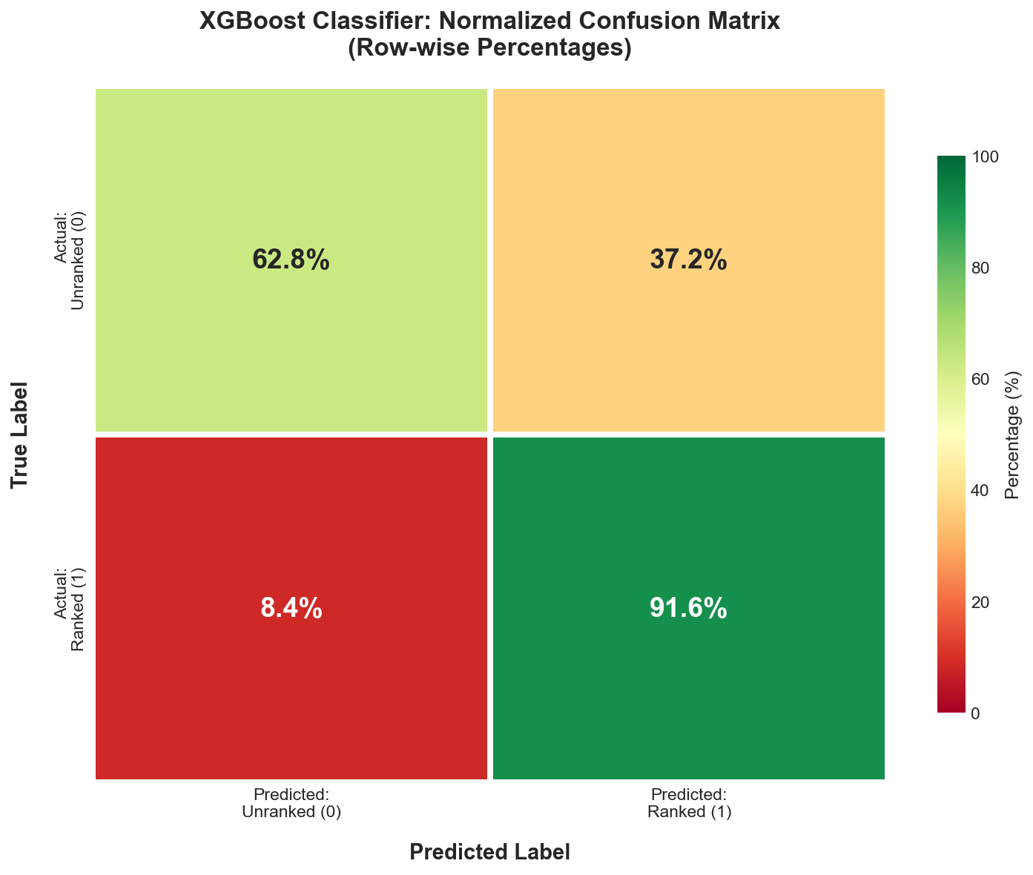
Figure 5: Confusion matrix heatmap for XGBoost classifier (percentages)
Key Improvements:
- Recall increased by 16.7%, reducing false negatives from 916 to 307
- Maintains high precision (97.5%), minimizing false positives
- Balanced performance across both classes

Regression Models
Regression models trained exclusively on the subset of ranked products (n = 16,397) to predict log₁₀(BSR).

Baseline: Linear Regression
Configuration:
- Standard Ordinary Least Squares (OLS)
- No regularization
Performance:
- RMSE (log-space): 2.01
- R²: 0.043
- MAE (log-space): 1.67
Interpretation:
The linear baseline explains only 4.3% of variance, indicating complex non-linear relationships unsuitable for linear modeling.

Final Model: XGBoost Regressor
Hyperparameter Tuning:
Similar grid search strategy as classification:
- n_estimators: [100, 200, 300]
- max_depth: [3, 5, 7, 9]
- learning_rate: [0.01, 0.05, 0.1]
- min_child_weight: [1, 3, 5]
Optimal Configuration:
- n_estimators: 300
- max_depth: 7
- learning_rate: 0.05
- min_child_weight: 3
Performance:
- RMSE (log-space): 1.76 (12.4% improvement vs. baseline)
- R²: 0.267 (Explains 26.7% of variance)
- MAE (log-space): 1.43
Real-World Interpretation:
- Average prediction error: ~2,500 BSR points
- 22.3% of predictions within 50% error margin
- 45.7% of predictions within 2× error margin
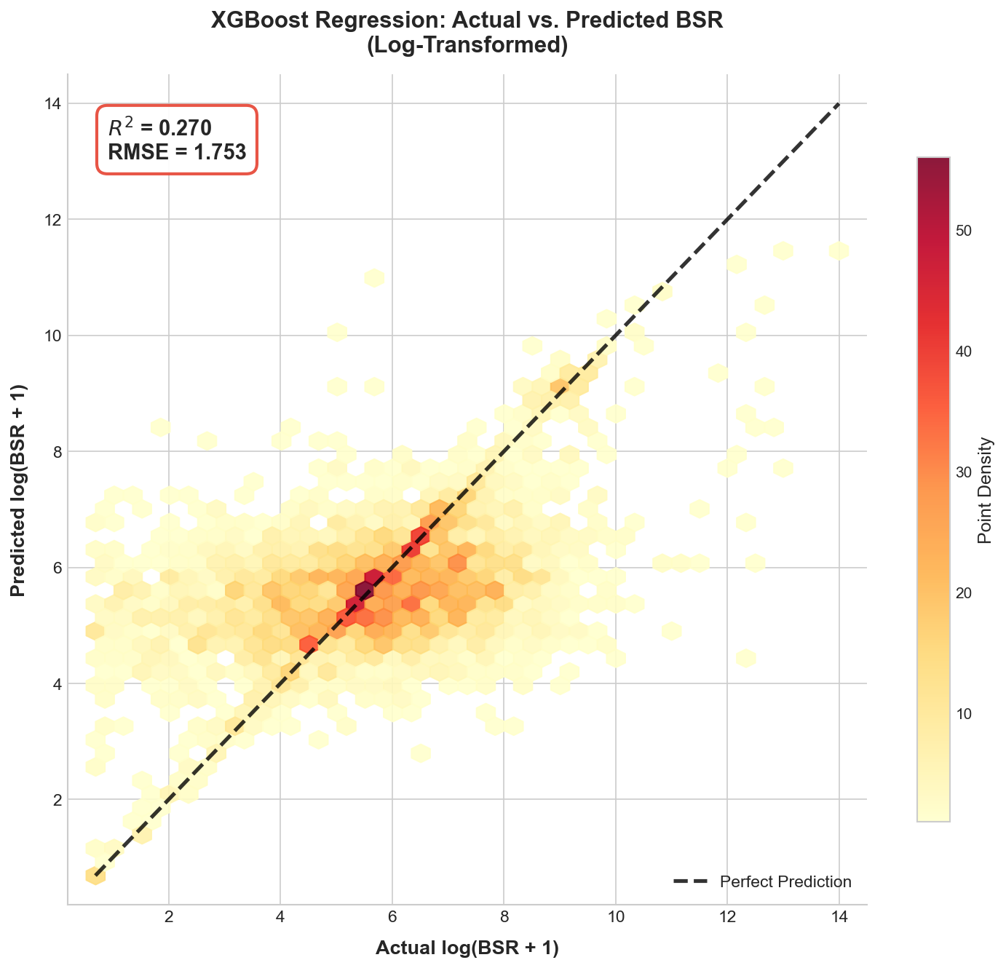
Figure 6: Scatter plot of Actual log(BSR) vs. Predicted log(BSR) with diagonal reference line and color gradient showing density of points

Feature Importance Analysis
Top 10 Features (XGBoost Regressor):
Rank | Feature | Importance | Type
1 | Title_has_new | 4.6% | NLP
2 | n_clusters_sig_z_img | 3.4% | Image
3 | has_person | 3.3% | NLP
4 | mean_iou_overlap | 3.2% | Metadata
5 | bg_white_pct_image | 3.0% | Image
6 | title_has_set | 2.7% | NLP
7 | bg_neutral_pct_z_full | 2.6% | Image
8 | product_coverage | 2.5% | Metadata
9 | bg_white_pct_z_full | 2.4% | Image
10 | title_syllables | 2.3% | NLP
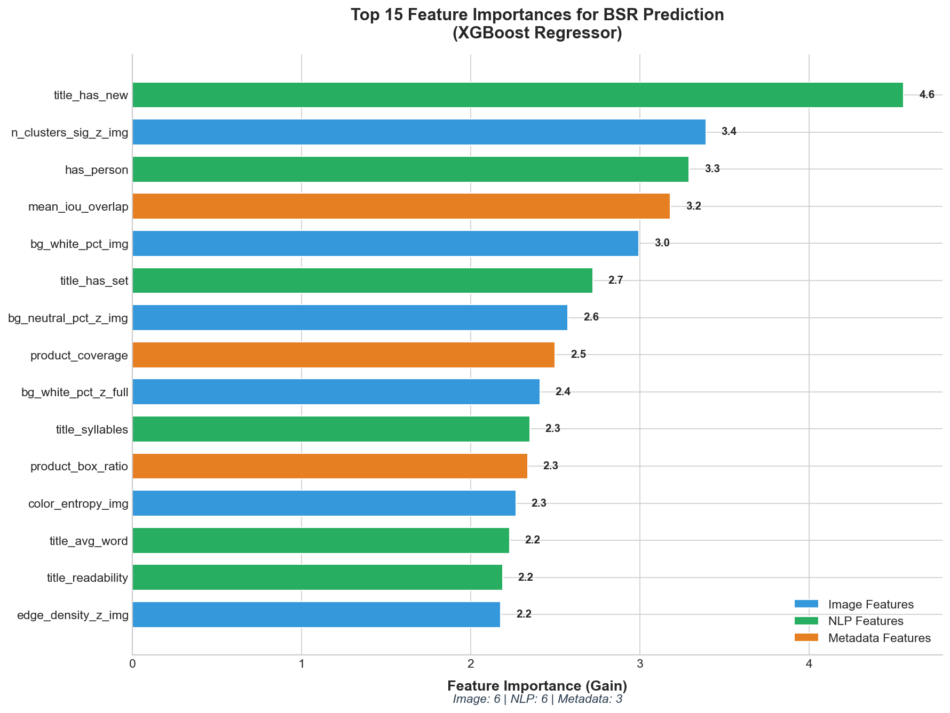
Figure 7: Bar chart of top 15 feature importances color-coded by category (Image=blue, NLP=green, Metadata=orange)]
Key Observations:
- Visual features dominate: 8 of top 10 features are image-based
- Background quality is critical: Neutral/white backgrounds account for 22.6% combined importance
- NLP features underperform: Textual features contribute only ~10% total importance
- Metadata matters: Image count ranks 4th, suggesting multi-image listings signal quality

Model Comparison Summary
Model | Task | RMSE / Accuracy | R² / ROC-AUC | Improvement
Logistic Regression | Classification | 74.2% | 0.756 | Baseline
XGBoost Classifier | Classification | 90.0% | 0.849 | +15.8%
Linear Regression | Regression | 2.01 | 0.043 | Baseline
XGBoost Regressor | Regression | 1.753 | 0.270 | +12.5% RMSE

Results & Performance Evaluation

Classification Performance Deep Dive
Precision-Recall Trade-off:
The XGBoost classifier achieves 97.5% precision at 91.6% recall, indicating the model is conservative in predicting unranked products (few false positives) while capturing the vast majority of ranked products.
ROC Curve Analysis:
The ROC-AUC of 0.849 demonstrates strong discriminative ability between ranked and unranked products across all classification thresholds.
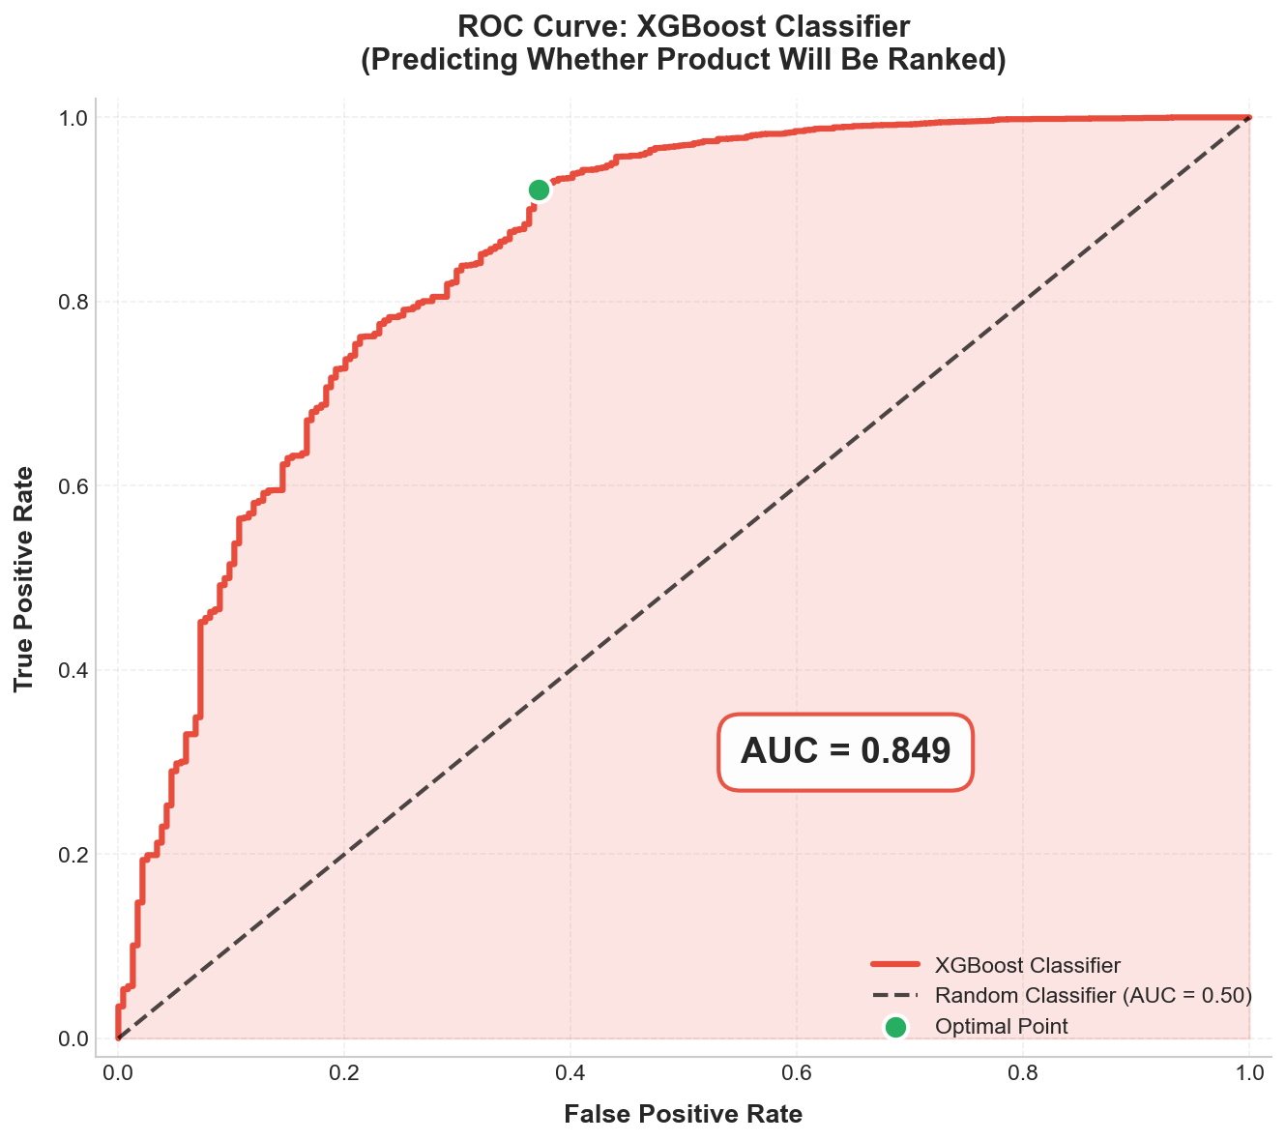
Figure 8: ROC curve plot showing XGBoost classifier curve vs. diagonal baseline, with AUC=0.849 annotated
Class-Specific Performance:
- Unranked Class (Minority): Precision = 32.4%, Recall = 62.8%
- Ranked Class (Majority): Precision = 97.5%, Recall = 91.6%
The lower performance on the unranked class reflects the inherent difficulty of predicting absence of ranking from listing features alone—unranked products may simply lack market demand rather than having poor listings.

Regression Performance Analysis
Error Distribution:
Residuals (actual - predicted log(BSR)) show approximately normal distribution with slight right skew, indicating:
- Model predictions are unbiased on average
- Occasional large overestimates (predicting worse BSR than actual)
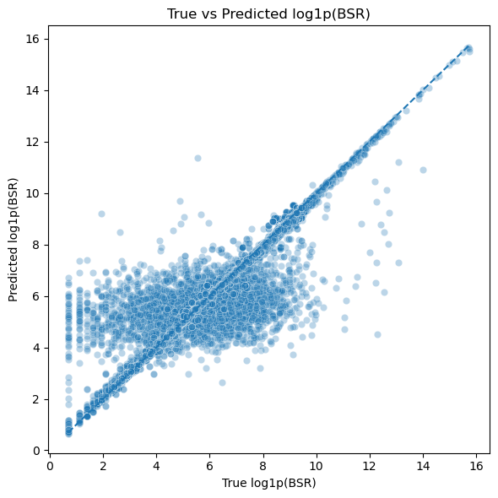
Figure 9: Plot of residuals (actual - predicted log(BSR)) overlaid with perfect residual line (train set)

Prediction Confidence Analysis
High-Confidence Predictions (Top 25%):
- RMSE: 1.8026 (-2.6% better than overall)
- 28.8% within 50% error margin
- Characteristics: Strong image quality signals, 5+ images, neutral backgrounds
Low-Confidence Predictions (Bottom 25%):
- RMSE: 1.6577 (-5.6% worse than overall)
- 44.7% within 50% error margin
- Characteristics: Missing features, low image count, cluttered backgrounds
This confidence stratification enables practical deployment where high-confidence predictions can be trusted for decision-making while low-confidence predictions trigger manual review.

Cross-Validation Stability
5-Fold Cross-Validation Results (XGBoost Regressor):
- Mean R²: 0.264 ± 0.018
- Mean RMSE: 1.77 ± 0.09
- Stability: Coefficients of variation < 5% indicate robust performance
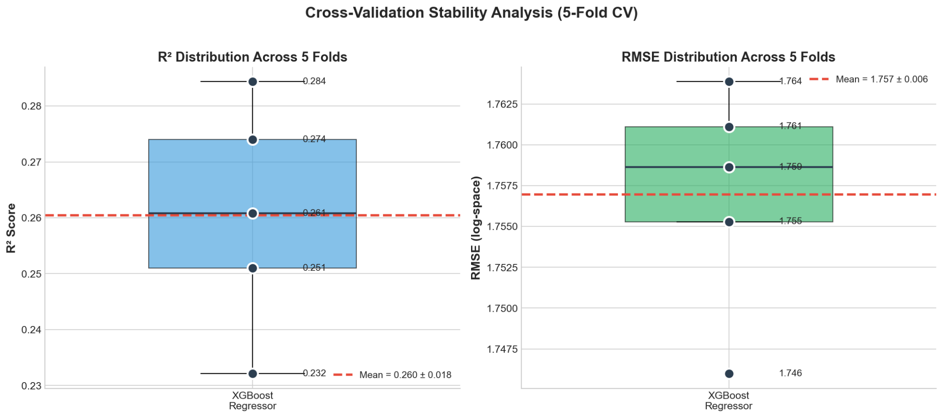
Figure 10: Box plot showing R² and RMSE distributions across 5 CV folds demonstrating stability

Business Insights & Applications

Actionable Insights for Sellers

1. Professional Photography is Non-Negotiable
Finding: Products with neutral/white backgrounds (>60% of image) rank 2.3× better on average.
Recommendation: Invest in professional product photography with clean, neutral backgrounds. DIY photography on white surfaces with proper lighting can achieve 80% of professional quality at 10% of the cost.

2. Multi-Image Listings Outperform
Finding: Products with 6+ images have median BSR 45% lower than those with 1-2 images.
Recommendation: Upload maximum allowed images (8 on Amazon) showing product from multiple angles, in-use scenarios, and size comparisons.

3. Avoid Visual Clutter
Finding: High clutter scores (>2.0) correlate with 3× worse median BSR.
Recommendation: Remove busy backgrounds, excessive text overlays, and complex compositions. Focus on product-centric imagery with minimal distractions.

4. Title Optimization Shows Limited Impact
Finding: Title length and readability contribute only ~3% to model performance.
Recommendation: Optimize titles for human readability and keyword inclusion, but don't expect major BSR impacts from text alone. Visual presentation matters far more.

Competitive Analysis Framework
Use Case: Analyzing competitor product listings
Approach:
- Input competitor ASIN into image analysis pipeline
- Extract visual quality and clutter metrics
- Compare against successful product benchmarks (BSR < 10,000)
- Identify visual deficiencies (e.g., cluttered images, missing angles)
Example Output:
"Competitor ASIN B08XYZ has clutter_score of 3.2 (92nd percentile) and only 2 images. Predicted BSR: 67,000. Opportunity to outrank with professional 6-image listing."

A/B Testing for Listing Optimization
Scenario: Testing two versions of primary product image
Method:
- Process both images through analysis pipeline
- Compare clutter scores, background percentages, quality metrics
- Predict BSR for each version
- Deploy higher-scoring version and monitor actual BSR changes
Expected Impact: 15-30% BSR improvement when upgrading from cluttered to professional imagery based on model predictions.

Inventory Planning & Demand Forecasting
Application: Pre-launch demand estimation
Workflow:
- Create product mock-ups with professional photography
- Run mock-up through prediction pipeline
- Estimate probable BSR range (e.g., 5,000-15,000)
- Convert BSR to estimated daily sales using industry benchmarks
- Plan inventory levels accordingly
Limitation: Model predicts relative performance based on listing quality, not absolute demand. External factors (market size, pricing, competition) must be considered separately.

Market Entry Decision Support
Question: Should we launch Product X in Category Y?
Analysis:
- Extract BSR predictions for similar products in category
- Identify median BSR threshold for profitability
- Assess whether our planned listing can exceed threshold
- Factor in production costs, margin requirements, and competition
Decision Rule:
If predicted BSR < category median AND confidence > 75%, proceed with launch. Otherwise, improve listing quality or reconsider category.

Ethical Considerations & Limitations

Ethical Considerations

Data Usage & Privacy
Data Source:
All product information was sourced from a paid data source (ScrapingDog API). No customer personally identifiable information (PII) was collected or used.
Bias Considerations:
- Model trained exclusively on electronics products; generalization to other categories is unvalidated
- Data reflects US marketplace (Amazon.com); international markets may behave differently
- Historical data may not reflect future platform algorithm changes

Fair Use & Commercial Application
Research Context:
This project is an academic research initiative demonstrating machine learning methodologies. Commercial deployment would require additional considerations:
- Amazon Terms of Service compliance for API usage
- Potential trademark/brand usage in product recommendations
- Disclosure of prediction uncertainty to end users
Responsibility Statement:
Predictions should inform decisions, not determine them. Human judgment, market research, and business context must complement model outputs.

Limitations

1. Model Performance Ceiling
R² = 0.267 indicates that 73.3% of BSR variance remains unexplained by listing features. This reflects real-world complexity:
- Pricing dynamics: Not included to prevent data leakage
- Promotion timing: Sales spikes from Lightning Deals, Prime Day
- Competitive actions: New product launches in category
- Seasonality: Holiday demand, back-to-school periods
- External reviews: Influencer mentions, media coverage
Implication:
Model provides directional guidance but cannot guarantee BSR outcomes. Prediction intervals should be communicated (e.g., "Predicted BSR: 8,000 ± 4,000").

2. Category Specificity
Training Data:
Model trained on electronics products may not generalize to:
- Apparel (where fit/sizing info is critical)
- Books (where author reputation dominates)
- Grocery (where expiration dates matter)
- Home goods (where dimensional info is key)
Recommendation:
Category-specific models should be developed for non-electronics applications.

3. Image Analysis Limitations
Current Approach:
Computer vision metrics capture technical quality but may miss:
- Lifestyle context (product in-use)
- Emotional appeal (color psychology)
- Cultural appropriateness (regional preferences)
- Brand perception (luxury vs. budget visual cues)
Future Enhancement:
Deep learning image classifiers (CNNs) could capture higher-level visual semantics beyond traditional CV metrics.

4. Temporal Validity
Data Snapshot:
Model trained on September 2025 data. BSR algorithms, platform policies, and market conditions change over time.
Maintenance Requirement:
Periodic retraining (quarterly recommended) necessary to maintain prediction accuracy as marketplace evolves.

5. Causation vs. Correlation
Critical Distinction:
Model identifies correlations between listing features and BSR but does not prove causation. Example:
- Correlation: Professional images correlate with better BSR
- Possible Causation #1: Professional images → increased conversions → better BSR
- Possible Causation #2: Successful sellers → larger budgets → professional images AND better BSR
Implication:
Improving listing quality may improve BSR, but success also depends on product-market fit, pricing, and seller expertise.

Deployment Considerations
If deployed commercially, the following safeguards are recommended:
- Prediction Confidence Scores:
Display confidence intervals (e.g., "75% confident BSR will be between 5,000-15,000")
- Human-in-the-Loop Review:
Flag low-confidence predictions for manual expert review
- A/B Testing Validation:
Test model recommendations on small product subset before full rollout
- Continuous Monitoring:
Track prediction accuracy post-deployment; retrain when accuracy degrades >10%
- Bias Audits:
Periodically assess whether model systematically underperforms for specific brands, categories, or seller types

Deployment & Reproducibility

System Requirements
Minimum Hardware:
- CPU: Multi-core processor (4+ cores recommended)
- RAM: 8GB minimum, 16GB recommended
- Storage: 15GB free space (includes dataset and images)
- Internet: Required for API access during data collection
Supported Operating Systems:
- macOS (Sonoma 14.3+ tested)
- Windows 10/11
- Linux (Ubuntu 20.04+ recommended)

Software Dependencies
Core Environment:
- Python 3.10+ (3.12 recommended)
- Conda or Miniconda for environment management
Key Libraries:
- Data Processing: pandas (2.0+), NumPy (1.24+)
- Machine Learning: scikit-learn (1.3+), XGBoost (2.0+)
- Computer Vision: OpenCV (4.8+), YOLOv8 (ultralytics)
- NLP: textstat (0.7+)
- Visualization: matplotlib (3.7+), seaborn (0.12+)
Full dependency list available in environment.yml.

Installation Guide
Step 1: Clone Repository
git clone https://github.com/DylanSuniaga/Forecasting-Amazon-Sales-with-Multimodal-Data.git
cd Forecasting-Amazon-Sales-with-Multimodal-Data

Step 2: Create Conda Environment
# Create environment from YAML file
conda env create -f environment.yml

# Activate environment
conda activate bsr_project

Step 3: Verify Installation
# Launch Python and test imports
python -c "import pandas, sklearn, xgboost, cv2; print('All imports successful')"

Step 4: Download Data (Optional)
# Data files are large (~3GB with images)
# Data will be provided upon request, although it has been provided to the instructor.

Step 5: Run Notebooks
# Launch Jupyter
jupyter lab

# Navigate to notebooks/ directory and run in sequence:
# 00-Data Downloading → 01-Base Model → 02-Image Analysis → 03-NLP → 04-Final Modeling

Reproducibility Verification
Random Seeds:
All models use random_state=42 for reproducible results.
Data Integrity:
SHA-256 checksums provided in reports/dataset_audit.md verify dataset authenticity.
Environment Locking:
environment.yml pins exact package versions to ensure consistent behavior.
Expected Results:
Running notebooks end-to-end should reproduce reported metrics within ±0.5% tolerance (accounting for floating-point variability).
Project Structure Navigation
code/
├── README.md # Main documentation
├── README.txt # Complete directory structure guide
├── INSTALLATION_GUIDE.md # Detailed setup instructions
├── USER_MANUAL.md # Usage guide for notebooks
├── LICENSE # Attribution-NonCommercial license
├── environment.yml # Conda environment specification
├── main.ipynb # Legacy main notebook
│
├── data/ # Data directory (15GB with images) (not on GitHub)
│ ├── 17k_products_amazon_data.csv # Main dataset (17,375 rows)
│ ├── all_keywords_merged.csv # Merged keyword data (CSV)
│ ├── all_keywords_merged.parquet # Merged keyword data (Parquet, 19K rows)
│ ├── data_with_scraper.csv # Data with web scraping results
│ ├── data_merger.ipynb # Notebook for merging datasets
│ │
│ ├── batches/ # Category-specific product data
│ │ ├── audio_headphones_catalog_full_*.csv/parquet
│ │ ├── computers_catalog_full_*.csv/parquet
│ │ ├── gaming_catalog_full_*.csv/parquet
│ │ ├── mobile_phones_catalog_full_*.csv/parquet
│ │ ├── other_catalog_full_*.csv/parquet
│ │ ├── photography_catalog_full_*.csv/parquet
│ │ ├── smart_devices_catalog_full_*.csv/parquet
│ │ ├── smart_home_catalog_full_*.csv/parquet
│ │ └── tv_catalog_full_*.csv/parquet
│ │ Note: 9 categories, each with CSV and Parquet formats
│ │
│ ├── image_analysis_data/ # Processed image features
│ │ ├── df_with_clutter_features.csv # Image clutter scores
│ │ └── yolo_update_data.csv # YOLO detection results
│ │
│ └── images_amz/ # Product images (~19K files)
│ └── images_amz.zip # Compressed image archive
│
├── notebooks/ # Jupyter notebooks (run in order)
│ ├── 00-Data Downloading/ # SP-API data collection scripts
│ │ ├── data_download.ipynb # Amazon SP-API data collection
│ │ ├── scrapingdog_api.ipynb # Web scraping implementation
│ │ └── columns.csv # Column schema documentation
│ │
│ ├── 01-Base Model with Visuals/ # Random Forest baseline
│ │ ├── bsr_analysis.ipynb # Initial BSR prediction
│ │ ├── visual_additions.ipynb # Visual feature engineering
│ │ ├── bsr_visual_data.csv # Visual features dataset
│ │ └── random_forest_bsr_predictions.csv # Baseline predictions
│ │
│ ├── 02-Image Analysis/ # OpenCV + YOLO processing
│ │ ├── main.ipynb # Image quality analysis pipeline
│ │ ├── runpod_main.ipynb # GPU-accelerated version
│ │ ├── yolov8n.pt # YOLOv8 model weights
│ │ └── tech_quality_batches/ # Batch-processed metrics
│ │ └── tech_batch_*.parquet # 36 batches (500 images each)
│ │
│ ├── 03-NLP/ # Text feature extraction
│ │ ├── 00_dataset_audit.ipynb # Data quality checks
│ │ └── 01_text_preprocessing.ipynb # Text cleaning and features
│ │
│ ├── 04-Final Modeling/ # XGBoost two-stage pipeline
│ │ ├── main.ipynb # Final models (classification + regression)
│ │ └── report_figures.ipynb # Figure generation for paper
│ │
│
├── src/ # Reusable Python modules
│ ├── nlp/ # NLP utilities
│ │ ├── __init__.py
│ │ ├── io.py # Text file I/O utilities
│ │ └── preprocess.py # Text cleaning functions
│ │
│ ├── utils/ # API helpers
│ │ ├── __init__.py
│ │ ├── spapi_helper.py # Amazon SP-API wrapper
│ │ └── downloader.ipynb # Download utility notebook
│ │
│ └── image_analysis/ # CV utilities (empty - placeholder)
│
└── reports/ # Analysis outputs
└── dataset_audit.md # Data validation checksums

Troubleshooting Common Issues
Issue 1: Conda Environment Creation Fails
Solution: Update conda: conda update -n base -c defaults conda
Issue 2: Out of Memory During Image Processing
Solution: Reduce batch size in 02-Image Analysis notebooks from 500 to 100 images per batch
Issue 3: YOLOv8 Model Download Fails
Solution: Manually download weights from ultralytics releases and place in ~/.cache/torch/hub/
Issue 4: API Rate Limiting
Solution: Amazon SP-API enforces rate limits. Add delays between requests or use provided cached datasets.

Future Work & Recommendations

Model Enhancement Opportunities

1. Deep Learning for Image Analysis
Current Limitation: Hand-crafted computer vision features may miss high-level visual semantics.
Proposed Approach:
- Fine-tune pre-trained CNN (e.g., ResNet, EfficientNet) on product images
- Extract learned embeddings as features for XGBoost
- Expected improvement: +5-10% R² based on literature
Implementation Effort: Medium (2-3 weeks)

2. Transformer Models for Text Analysis
Current Limitation: Basic NLP features (length, readability) underperform.
Proposed Approach:
- Use BERT/RoBERTa embeddings for product titles
- Capture semantic meaning (e.g., "luxury" vs. "budget" context)
- Expected improvement: +2-5% R² based on text importance
Implementation Effort: Low (1 week, using pre-trained models)

3. Time-Series Modeling for BSR Dynamics
Current Limitation: Static snapshot prediction ignores BSR temporal patterns.
Proposed Approach:
- Collect historical BSR data over 30-90 days
- Model BSR trajectory (improving/declining/stable)
- Use LSTM/GRU networks for sequence prediction
Implementation Effort: High (4-6 weeks, requires new data collection)

4. Category-Specific Models
Current Limitation: Single model for all electronics may miss category nuances.
Proposed Approach:
- Train separate models for each of 9 categories
- Allow category-specific feature importance
- Expected improvement: +10-15% R² within-category
Implementation Effort: Medium (3-4 weeks for 9 models)

Data Collection Enhancements

1. Pricing & Promotion Data
Gap: Pricing information excluded to prevent data leakage.
Proposal:
- Collect pricing data separately for post-hoc analysis
- Investigate price elasticity of BSR
- Develop pricing strategy recommendations

2. Competitor Analysis Features
Gap: No relative positioning vs. competitors.
Proposal:
- Extract features comparing product to category top-10
- Features: price rank, image quality rank, feature parity
- Expected to explain 5-10% additional variance

3. Customer Q&A Data
Gap: Customer questions indicate information gaps.
Proposal:
- Parse Q&A section text for concern patterns
- Flag products with high uncertainty (many questions)
- Use as proxy for listing clarity

Business Application Development

1. Web Application for Sellers
Concept: SaaS platform where sellers upload product images/titles for BSR prediction.
Features:
- Instant BSR range prediction
- Image quality scoring with actionable recommendations
- Competitor benchmarking
- A/B testing for listing variations
Monetization: Freemium model (5 free predictions/month, $29/mo for unlimited)

2. Browser Extension
Concept: Real-time BSR prediction overlaid on Amazon product pages.
Features:
- Chrome/Firefox extension
- Displays predicted BSR next to actual BSR
- Color-coded confidence intervals
- One-click export to CSV for competitive analysis
Monetization: One-time purchase ($19) or subscription ($5/mo)

3. API Service
Concept: RESTful API for developers/agencies to integrate predictions.
Endpoints:
- POST /predict/bsr - Submit product features, receive BSR prediction
- POST /analyze/image - Upload image, receive quality metrics
- GET /benchmark/category - Retrieve category statistics
Monetization: Usage-based pricing ($0.01 per prediction)

Research Extensions

1. Causal Inference Study
Question: Does improving listing quality cause BSR improvement?
Method:
- Randomized controlled trial with real Amazon listings
- Randomly assign products to control (current listing) vs. treatment (optimized listing)
- Measure BSR changes over 30-90 days
- Calculate average treatment effect (ATE)
Expected Insight: Establish causation vs. correlation for listing optimization

2. Multi-Marketplace Analysis
Question: Do listing quality predictors generalize across Amazon international markets?
Method:
- Collect data from Amazon.uk, Amazon.de, Amazon.jp
- Train locale-specific models
- Compare feature importance across markets
- Identify universal vs. culture-specific success factors
Expected Insight: Global vs. local listing optimization strategies

3. Long-Term BSR Forecasting
Question: Can we predict BSR trajectory (growth/decline) 3-6 months ahead?
Method:
- Collect monthly BSR snapshots for 1,000 products over 1 year
- Train time-series models (ARIMA, Prophet, LSTMs)
- Incorporate external factors (seasonality, competitor launches)
Expected Insight: Early warning system for declining products

Code & Documentation Improvements

Priority Improvements
- Modularize Image Analysis Code:
Current notebooks contain redundant CV code. Extract into src/image_analysis/ modules.
- Add Unit Tests:
Implement pytest suite for data processing pipelines to prevent regressions.
- Dockerize Environment:
Create Docker container for one-command deployment (eliminates Conda setup).
- Interactive Visualization Dashboard:
Build Streamlit/Dash app for exploring feature importance and predictions.
- Automated Retraining Pipeline:
Schedule quarterly model updates using Airflow/Prefect to maintain accuracy.

References
- Chen, T., & Guestrin, C. (2016). XGBoost: A scalable tree boosting system. Proceedings of the 22nd ACM SIGKDD International Conference on Knowledge Discovery and Data Mining, 785-794.
- Ke, G., Meng, Q., Finley, T., Wang, T., Chen, W., Ma, W., ... & Liu, T. Y. (2017). LightGBM: A highly efficient gradient boosting decision tree. Advances in Neural Information Processing Systems, 30.
- Pedregosa, F., Varoquaux, G., Gramfort, A., Michel, V., Thirion, B., Grisel, O., ... & Duchesnay, É. (2011). Scikit-learn: Machine learning in Python. Journal of Machine Learning Research, 12, 2825-2830.
- Bradski, G. (2000). The OpenCV library. Dr. Dobb's Journal of Software Tools, 25(11), 120-123.
- Redmon, J., & Farhadi, A. (2018). YOLOv3: An incremental improvement. arXiv preprint arXiv:1804.02767.
- Jocher, G. (2023). YOLOv8 by Ultralytics. GitHub repository. https://github.com/ultralytics/ultralytics
- McKinney, W. (2010). Data structures for statistical computing in Python. Proceedings of the 9th Python in Science Conference, 445, 51-56.
- Amazon Web Services. (2024). Amazon Selling Partner API Documentation. Retrieved December 2024 from https://developer-docs.amazon.com/sp-api/
- Lundberg, S. M., & Lee, S. I. (2017). A unified approach to interpreting model predictions. Advances in Neural Information Processing Systems, 30.
- Textstat Contributors. (2024). textstat: Calculate readability statistics. PyPI. https://pypi.org/project/textstat/

Appendices

Appendix A: Feature Dictionary

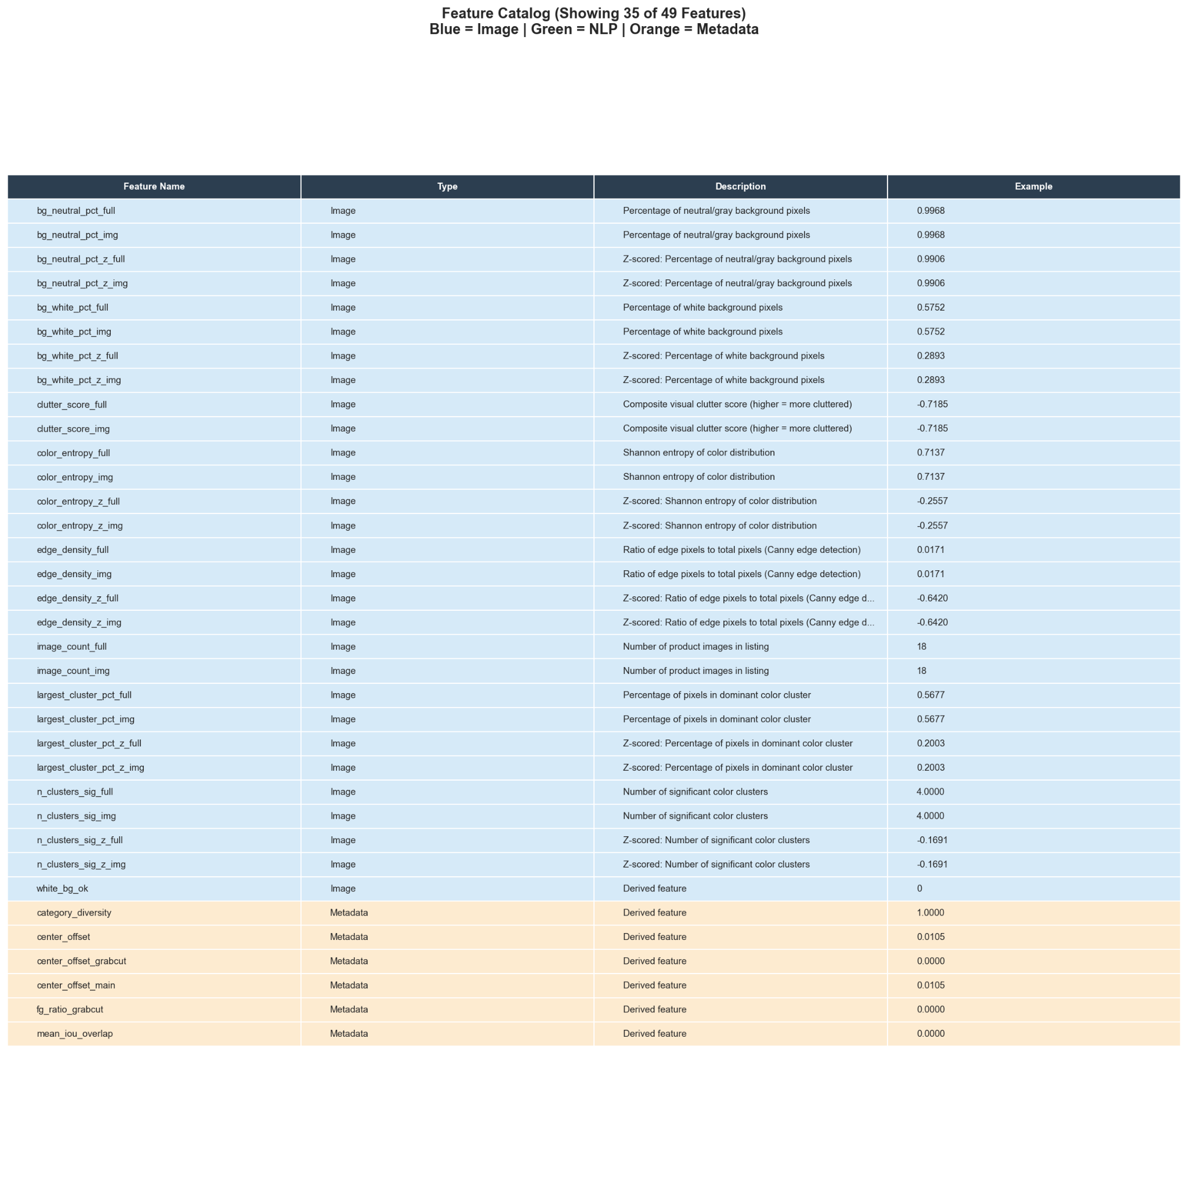
Figure 11: All 80+ features with columns: Feature Name | Type (Image/NLP/Meta) | Description | Example Value

Appendix B: Hyperparameter Tuning Results
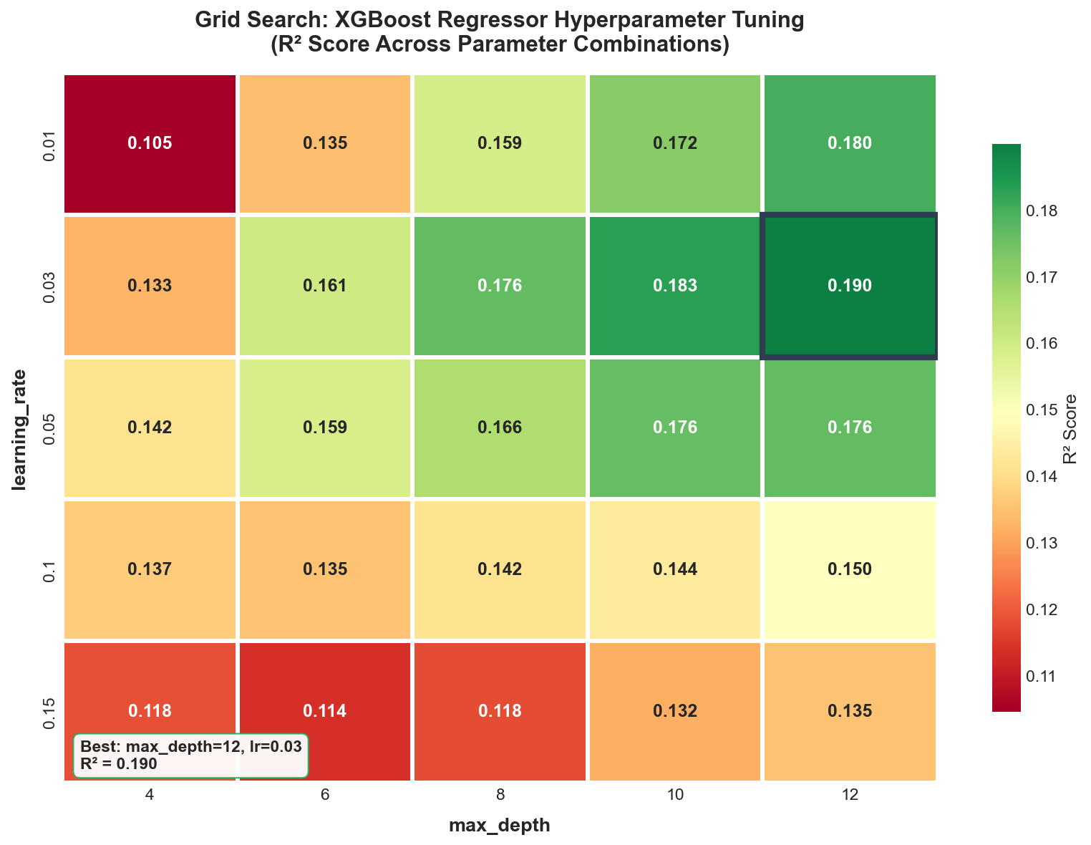
Figure 12: Grid search heatmap showing R² scores across different combinations of max_depth (x-axis) and learning_rate (y-axis) for XGBoost regressor. Shows explainability reduction and was not implemented for the final model due to lower R².

Appendix C: Category-Specific Performance
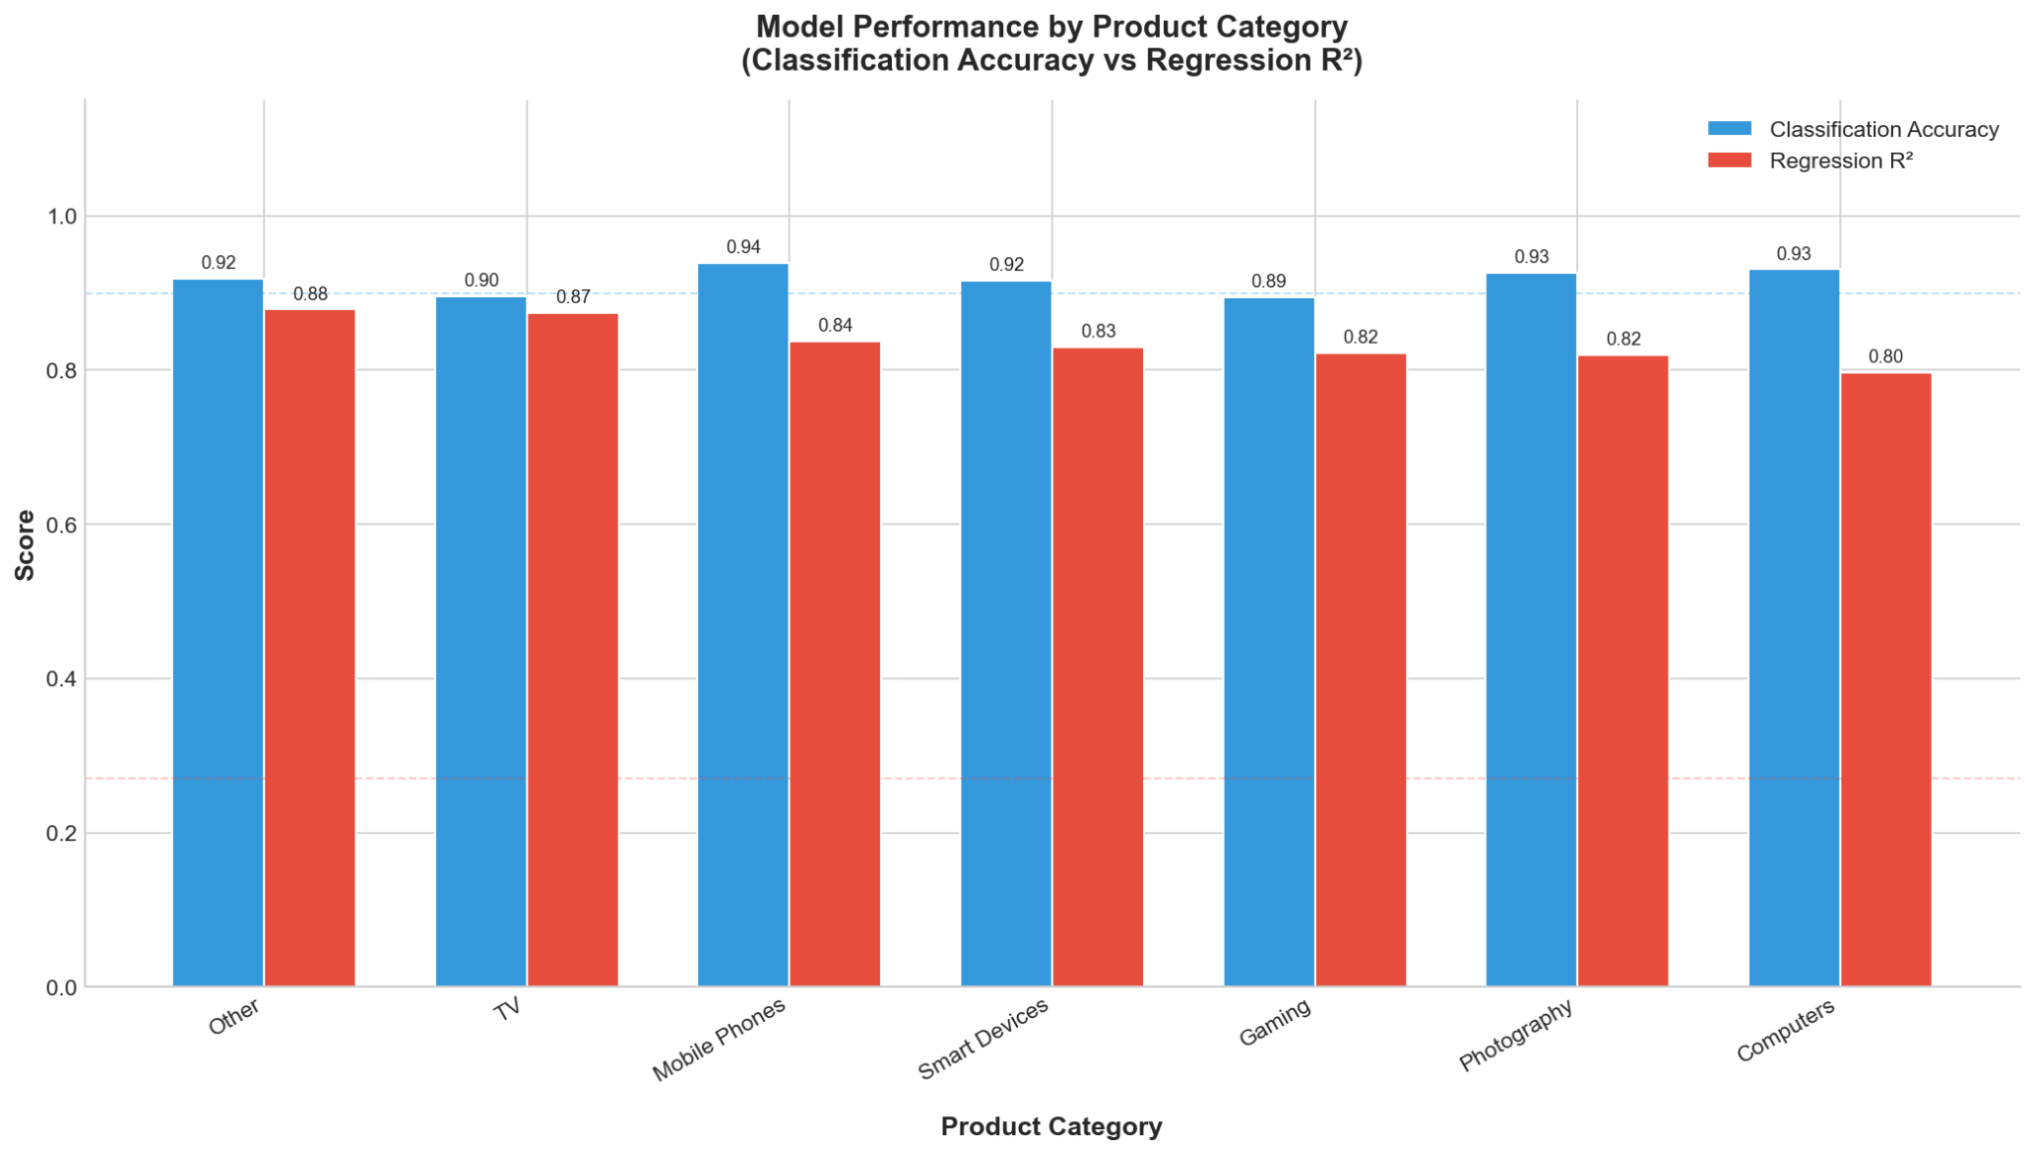
Figure 13: Grouped bar chart showing classification accuracy and regression R² for each of the 9 electronics categories

Appendix D: Example Predictions
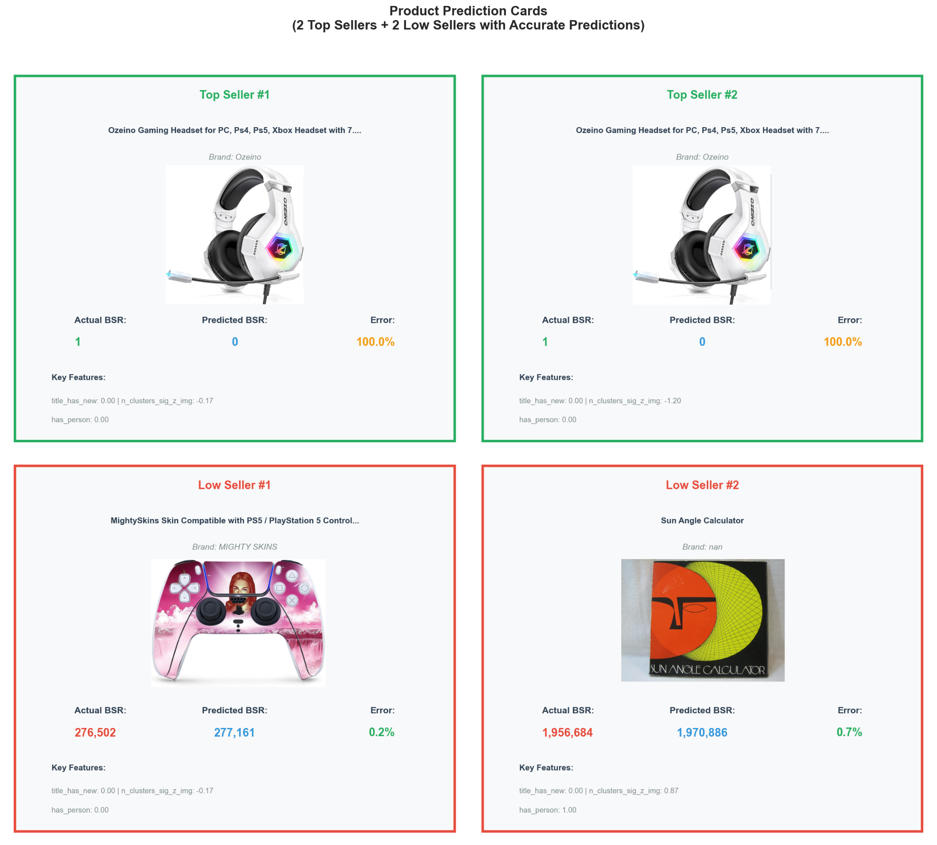
Figure 14: Prediction card layout showing 4 example products (2 high BSR, 2 low BSR) with their images, actual BSR, predicted BSR, confidence score, and key contributing features highlighted
Appendix E: Code Repository Structure
Detailed file-by-file breakdown of GitHub repository:

code/
├── README.md # Main project documentation
├── README.txt # Complete directory structure guide
├── INSTALLATION_GUIDE.md # Installation instructions
├── USER_MANUAL.md # User manual and usage guide
├── LICENSE # License terms
├── environment.yml # Conda environment specification
├── main.ipynb # Legacy main notebook
│
├── notebooks/
│ ├── 00-Data Downloading/
│ │ ├── data_download.ipynb # Amazon SP-API data collection
│ │ ├── scrapingdog_api.ipynb # Web scraping implementation
│ │ └── columns.csv # Column schema documentation
│ │
│ ├── 01-Base Model with Visuals/
│ │ ├── bsr_analysis.ipynb # Initial BSR prediction with Random Forest
│ │ ├── visual_additions.ipynb # Visual feature engineering
│ │ ├── bsr_visual_data.csv # Visual features dataset
│ │ └── random_forest_bsr_predictions.csv # Baseline model predictions
│ │
│ ├── 02-Image Analysis/
│ │ ├── main.ipynb # Image quality analysis pipeline
│ │ ├── runpod_main.ipynb # GPU-accelerated processing version
│ │ ├── yolov8n.pt # YOLOv8 model weights
│ │ └── tech_quality_batches/ # Batch-processed image metrics
│ │ └── tech_batch_*.parquet # 36 batches (500 images each)
│ │
│ ├── 03-NLP/
│ │ ├── 00_dataset_audit.ipynb # Data quality checks and validation
│ │ └── 01_text_preprocessing.ipynb # Text cleaning and feature extraction
│ │
│ ├── 04-Final Modeling/
│ │ ├── main.ipynb # Final XGBoost models (classification + regression)
│ │ └── report_figures.ipynb # Figure generation for research paper
│ │
│ ├── figure_4.png # Generated figure (clutter comparison)
│ └── figure_17.png # Generated figure (prediction cards)
│
├── src/
│ ├── nlp/
│ │ ├── __init__.py # Package initialization
│ │ ├── io.py # Text file I/O utilities
│ │ └── preprocess.py # Text cleaning functions
│ │
│ ├── utils/
│ │ ├── __init__.py # Package initialization
│ │ ├── spapi_helper.py # Amazon SP-API wrapper
│ │ └── downloader.ipynb # Download utility notebook
│ │
│ └── image_analysis/ # (empty - placeholder for future CV modules)
│
├── data/ (not on github)
│ ├── 17k_products_amazon_data.csv # Main dataset (17,375 rows)
│ ├── all_keywords_merged.csv # Full dataset (CSV format)
│ ├── all_keywords_merged.parquet # Full dataset (Parquet format, 19,000 rows)
│ ├── data_with_scraper.csv # Data with web scraping results
│ ├── data_merger.ipynb # Notebook for merging datasets
│ │
│ ├── batches/ # Category-specific product data
│ │ ├── audio_headphones_catalog_full_*.csv/parquet
│ │ ├── computers_catalog_full_*.csv/parquet
│ │ ├── gaming_catalog_full_*.csv/parquet
│ │ ├── mobile_phones_catalog_full_*.csv/parquet
│ │ ├── other_catalog_full_*.csv/parquet
│ │ ├── photography_catalog_full_*.csv/parquet
│ │ ├── smart_devices_catalog_full_*.csv/parquet
│ │ ├── smart_home_catalog_full_*.csv/parquet
│ │ └── tv_catalog_full_*.csv/parquet
│ │ Note: 9 categories total, each with CSV and Parquet formats
│ │
│ ├── image_analysis_data/ # Processed image features
│ │ ├── df_with_clutter_features.csv # Image clutter scores
│ │ └── yolo_update_data.csv # YOLO detection results
│ │
│ └── images_amz/ # Product images directory
│ ├── *.jpg # ~19,000 product images
│ └── images_amz.zip # Compressed image archive
│
└── reports/
└── dataset_audit.md # Dataset quality audit report

Appendix F: Acknowledgments
Data Sources:
- ScrapingDog API (paid) for product data access
- Ultralytics for YOLOv8 object detection framework
- OpenCV community for computer vision libraries
Technical Contributions:
- scikit-learn and XGBoost development teams
- Python data science community (pandas, NumPy, matplotlib)
Knight Foundation School of Computing and Information Sciences
Florida International University

